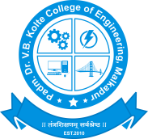 | LokSewaShikshanBahuuddeshiyaMandal  Padm.Dr.V.B.Kolte College of Engineering  Malkapur, DistBuldhana (MS) 443101  Ph:- Principal (07267) 226700 , Office:- (07267) 224943 Fax:- 07267-224943  Email: coemalkapur@rediffmail.comWebsite:-www.vbkcoemalkapur.org
 | Department:-Mechanical Engineering (Poly) | Academic Year:-2019-20
 | Page:-1 of 2
 | Activity:- Faculty Development Program
 | Summary Report
Date:-31/01/2020

Name of Programme :- Faculty Development Program On “Art of effective teaching”

A five day faculty development programme on “ Art of effective teaching" under was held in Mechanical Engineering Department at Padm. Dr V. B. Kolte College of Engineering Malkapur from 27th jan 2020 to 31th jan 2020. The FDP aimed to provide opportunities to faculty members to provide the importance of effective teaching techniques. This five days program is beneficial for all the facilities.

INAUGURAL SESSION:
The esteemed personalities present on the inauguration of the programme:

• Dr. A.W. Kharche, Principal, VBKCOE, Malkapur
• Mr. R. M. Choudhari academic dean, Vbkcoe malkapur
TECHNICAL SESSIONS

1 st Day (27/01/2020)
Morning Session :
Inauguration session conducted by Prof. R. M. Choudhari , on that occasion the inaugural speech given by our honourable principal Dr. A. W. Kharche and Mr. R. M. Choudhari.
An informative lecture on, “ Student Mentoring & Class Room Management”l
by Dr. A. K. Gupta. In this session participants were know about how to manage class room and students mentoring.

Afternoon Session :
LIn afternoon session Dr. A. W. Kharche given valuable guidance on, “ resent trends in education. From this session faculty will get information about recent trends in education.

.2nd Day ( 28/01/2020)
Morning Session :
An informative lecture on, “Concept of Outcome Based Education” by Dr. B. L. Gupta. In this session participants were get additional knowledge about outcome based Education. Also sir differentiate between general education and outcome based Education.
Afternoon Session :
An informative lecture on, “ Importance of teacher guardian” by Dr. B. L. Gupta. In this session participants were get additional knowledge about teacher guardian.

3rd day (29/01/2020)
Morning Session :
In morning session Mr. Sagar Bhagat Interaction with on topic, “How to develop E content”. In this session participants were know about process of E content development.

Afternoon Session :
An informative lecture on, “Innovation in teaching learning ” by Mr. Rajesh Umale. In this session participants were get additional knowledge about Innovation in teaching learning process.”

4th Day (30/01/2020)
Morning Session :

An informative lecture on, “Effective use of ICT classroom” by Mr. Sameer S. Sabhaptikar. In this session participants were get detailed knowledge about ICT classroom and it’s effective utilisation.

Afternoon Session :
An informative lecture on, “ Micro learning ” by Mr. Sachin Tambekar. In this session participants were get detailed knowledge about micro learning in which how to learn different things.

5th day (31/01/2020)
Morning Session :
In this ssessionMr. Sachin Tambekar conducted informative lecture on topic, “ Story Telling”. In this session participants were know about how to create interest in students while teaching.

Afternoon Session :
An informative lecture on, “ Art of effective teaching quizes, rewards and motivation” by Mr. D. E. Kinage In this session participants were get knowledge about Art of effective teaching quizes, rewards and motivation.
After this session end vote of thanks given by prof. S. R. Shekokar.

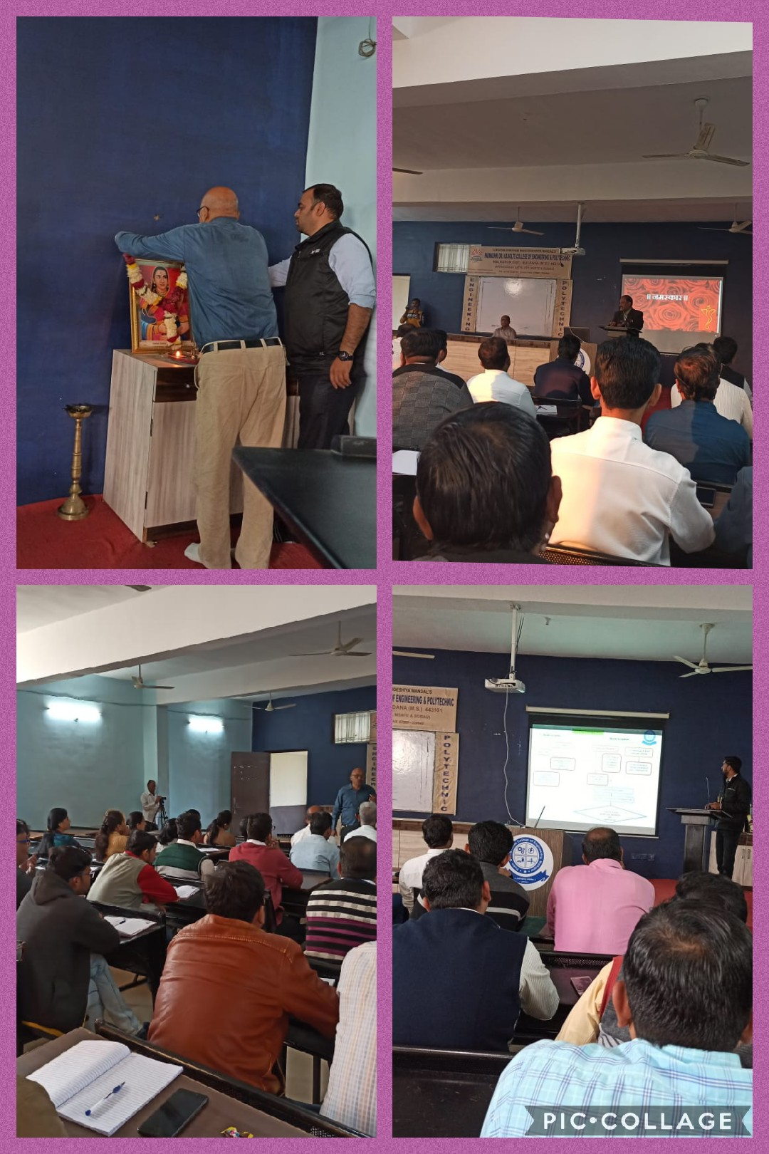
Snaps of FDP:

