Padm. Dr. V. B. Kolte College of Engineering, Malkapur

STAFF PROFILE

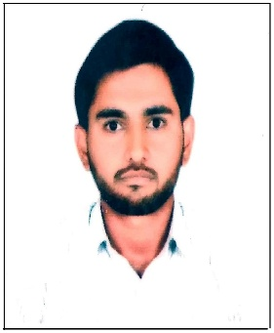 | Name : Mr. Dipak Raman Joshi  Designation: Lecturer
Qualifications : B.E
Area of Specialization: Electrical Engineering
Email- dipakjoshi.67@gmail.com
Date of Birth :06/07/1994
Date of Joining: 05/07/2017
Nature of Association: Regular

Academic Performance :
(High School to Highest Qualification.)
Exam | Passing Month & Year | Name & Address of College/School | Board | % Of Marks | Grade
S.S.C | March 2010 | Shri A. S. Vidyalaya, Shelapur Bk | Amravati | 69.60 | First Class
H.S.C | February 2012 | V. V. Junior College, Wakodi, Malkpaur | Amravati | 56.83 | Second Class
BE | June 2016 | Rajarshi Shahu College of Engineering, Buldhana | SGBAU Amravati | 6.80 | First Class
M. E. | - | Padm. Dr. V. B. Kolte College of Engineering, Malkapur | SGBAU Amravati | Pursuing | -
Ph.D. | - | - | - | - | -
Other Qualification | - | - | - | - | -

Experience :

TEACHING |  | INDUSTRIAL | TOTAL
VBKCOE | OTHER INST.
04 Year | - | - | 04 Year

Achievements (Qualification upgradation, book publish,curriculam manual design): - Number of Paper Published :
Paper Name | Publication Details | Date/Year of Paper  Published
Fault Current Mitigation and elimination in high voltage Transmission line with PSB, OST and FCL | IJSART - Volume 8 Issue 2 –February 2022 | February 2022

Award Winning: - ----Books/Journal/Magazine Published:
Sr. No | Books/ Journal Name/ Magazine | Publication
- | - | -

Conference/Seminar/Workshop/STTP/FDP Attended:
Sr. No | Type | Subject | Place | No. of days.
1. | FDP | SCILAB and  XCOS – FOSS Alternatives for MATLAB and SIMULINK" | CMR institute of Technology,  Bengaluru. | 05
2. | Workshop | Accreditation (NBA) awareness workshop | SGBAU, Amravati | 01
3

